Project Report
Streamlining IT Procurement:
Automating Standard Laptop Orders with Flow Designer
Platform | ServiceNow (Flow Designer, Service Catalog)
Program | SmartInternz / SmartBridge
Team ID | SWTID-2026-6870
Submitted by | HARISH V, Jairaj R, KARTHIKEYAN S, KARUPPUSAMY PRAVEEN N
Date | 04 October 2026

Contents
1. Introduction
2. Ideation Phase
3. Requirement Analysis
4. Project Design
5. Project Planning & Scheduling
6. Functional and Performance Testing
7. Results
8. Advantages & Disadvantages
9. Conclusion
10. Future Scope
11. Appendix

1. Introduction

1.1 Project Overview
In many organisations the IT procurement process for standard laptops is slow and manual. After a laptop request is approved, someone has to create a configuration task and assign it to the hardware team. This step is easy to miss or delay, which frustrates users and wastes IT resources.
This project uses ServiceNow Flow Designer to automate that step. A flow named "Standard laptop task" is triggered from the Service Catalog and uses the Create Catalog Task action to create a task with the short description "Laptop needs to Configured", assignment group Hardware and approval Approved. The flow is attached to the Standard Laptop catalog item, so every order produces the task automatically.

1.2 Purpose
- Create a seamless experience for users requesting standard laptops by ensuring timely configuration.
- Reduce manual intervention and potential errors in the procurement process.
- Improve resource utilisation in the IT department by optimising task allocation.
- Enhance overall efficiency and productivity in IT procurement operations.

2. Ideation Phase

2.1 Problem Statement
Standard laptop orders need configuration, but the configuration task is created and assigned manually and is often missed or delayed. Three users are affected: the IT procurement team member, the employee who requested the laptop, and the Hardware team member who configures it. The detailed statements (PS-1 to PS-3) are in the Define Problem Statements document.

2.2 Empathy Map Canvas
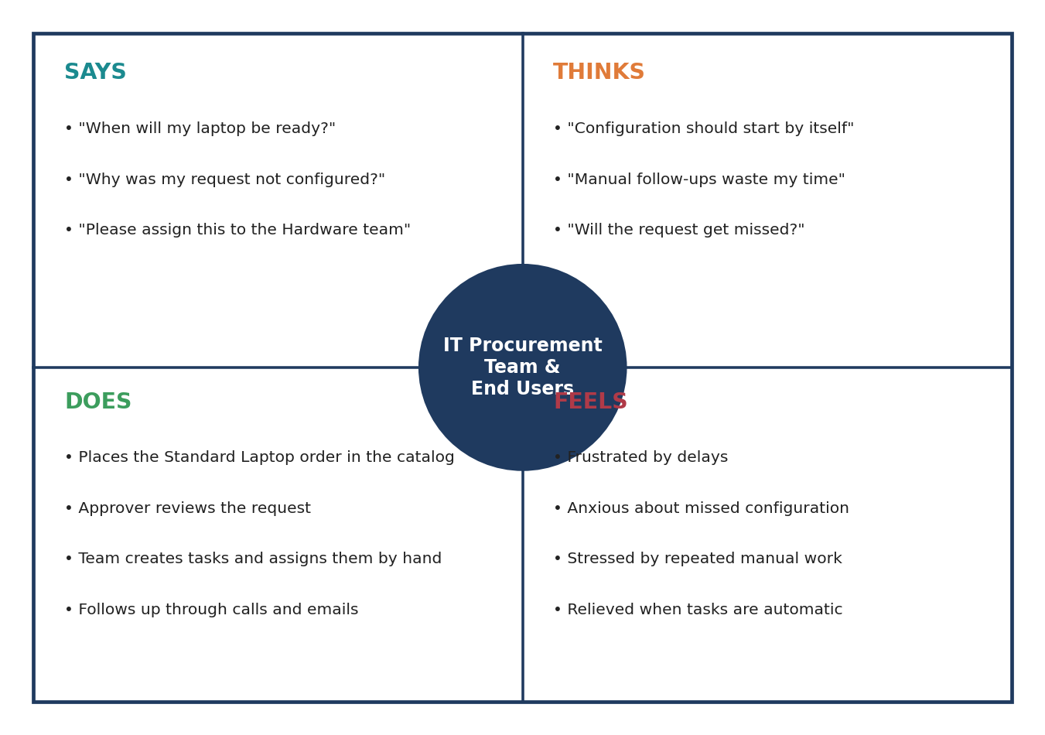
Figure 2.1: Empathy map

2.3 Brainstorming
The team listed ideas under automation, assignment, approval and tracking, and communication, then ranked them by impact and effort. The top ideas selected were the Flow Designer flow, automatic task creation, automatic assignment to Hardware and keeping the approval step.
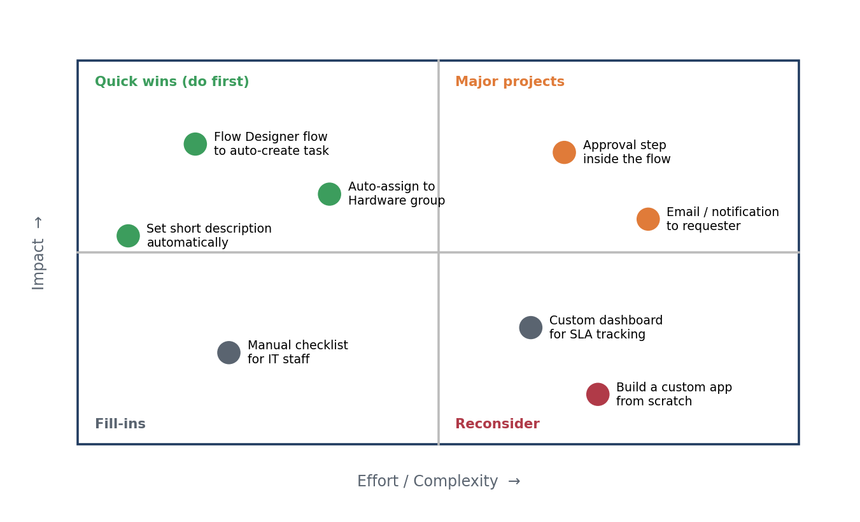
Figure 2.2: Idea prioritisation

3. Requirement Analysis

3.1 Customer Journey Map
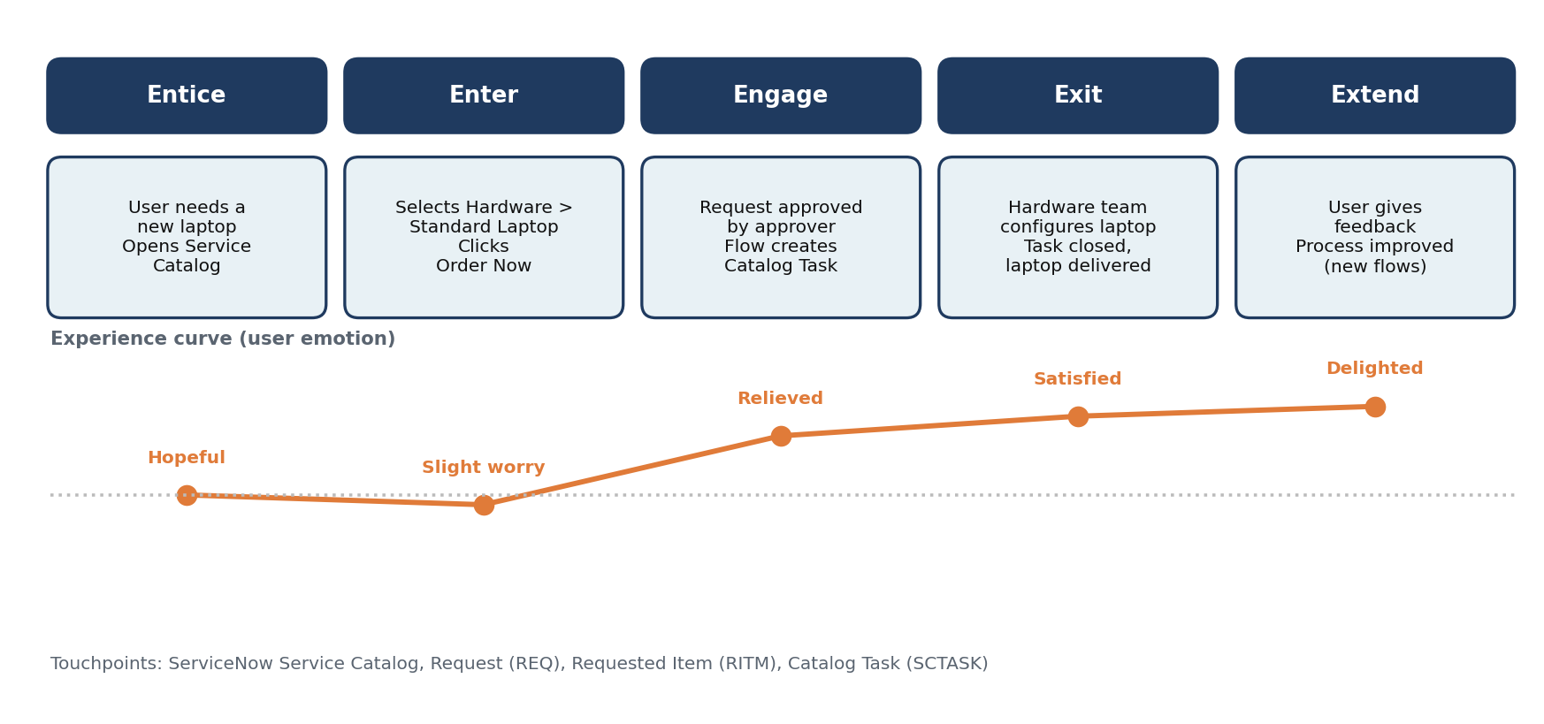
Figure 3.1: Customer journey map

3.2 Solution Requirement
Functional requirements: flow creation, Service Catalog trigger, Create Catalog Task action with field values, activation and assignment to the catalog item, ordering and approval, and verification of the generated task. Non-functional requirements: usability, security, reliability, performance, availability and scalability (see the Solution Requirements document).

3.3 Data Flow Diagram
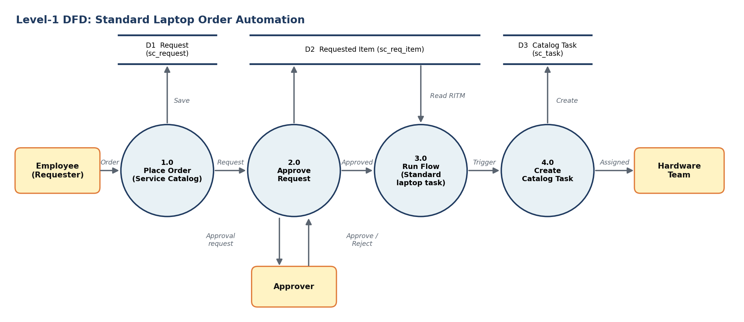
Figure 3.2: Level-1 data flow diagram

3.4 Technology Stack
Component | Technology
User interface | ServiceNow Service Catalog and platform forms
Application logic | Flow Designer flow with Service Catalog trigger; Create Catalog Task action
Database | ServiceNow tables sc_request, sc_req_item, sc_task
Hosting | ServiceNow cloud instance (Global scope)

4. Project Design

4.1 Problem Solution Fit
The problem is the missing link between an approved order and the Hardware team's configuration work. The solution fits the customers' behaviour because requesters keep using the Service Catalog and the flow works silently in the background, removing the need for manual task creation.

4.2 Proposed Solution
A low-code Flow Designer flow that creates a catalog task assigned to the Hardware group for every Standard Laptop order. It is novel in its simplicity, needs no scripting, and can be reused for other catalog items.

4.3 Solution Architecture
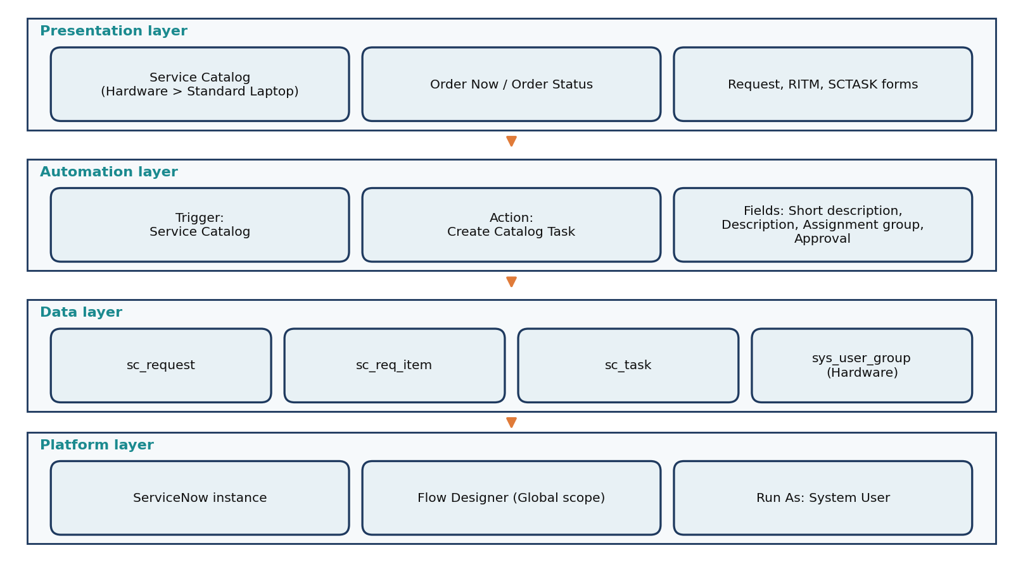
Figure 4.1: Solution architecture

5. Project Planning & Scheduling

5.1 Project Planning
The work was planned in two sprints. Sprint-1 (9 story points) covered flow creation and flow assignment. Sprint-2 (12 story points) covered ordering, approval, task verification, testing and documentation. Total scope was 21 story points with an average velocity of 10.5 story points per sprint.
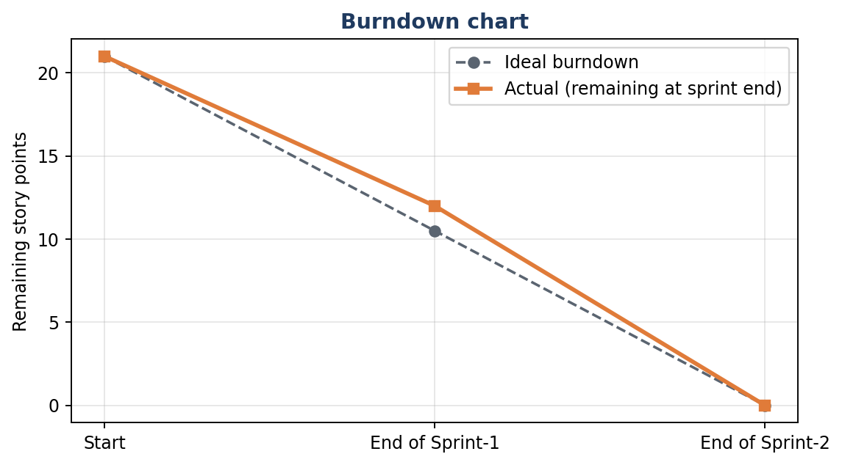
Figure 5.1: Burndown chart

6. Functional and Performance Testing

6.1 Performance Testing
Eleven test cases were defined: nine functional tests and two performance tests. Ten passed and one (multiple simultaneous orders) was not executed. No failures were recorded.
ID | Scenario | Result | Evidence
FT-01–04 | Flow creation, trigger, action, activation | Pass | Flow Designer screens
FT-05 | Flow assignment to Standard Laptop | Pass | Process Engine tab
FT-06–07 | Order placement and approval | Pass | REQ0010001, approver record
FT-08–09 | Catalog task generated with correct values | Pass | SCTASK0010001
PT-01 | Task creation time | Pass | Order 04:07:11; task start 04:11:40
PT-02 | Multiple simultaneous orders | Not tested | –

7. Results

7.1 Output Screenshots
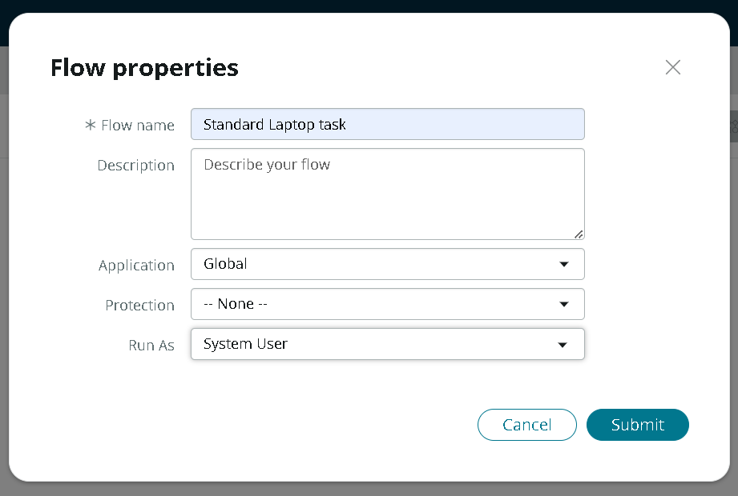
Figure 7.1: Flow properties – Standard Laptop task
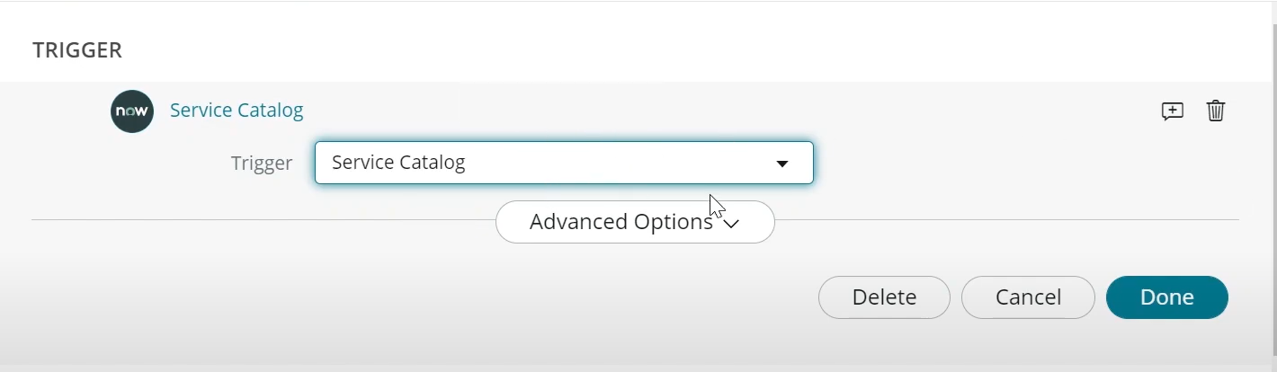
Figure 7.2: Service Catalog trigger
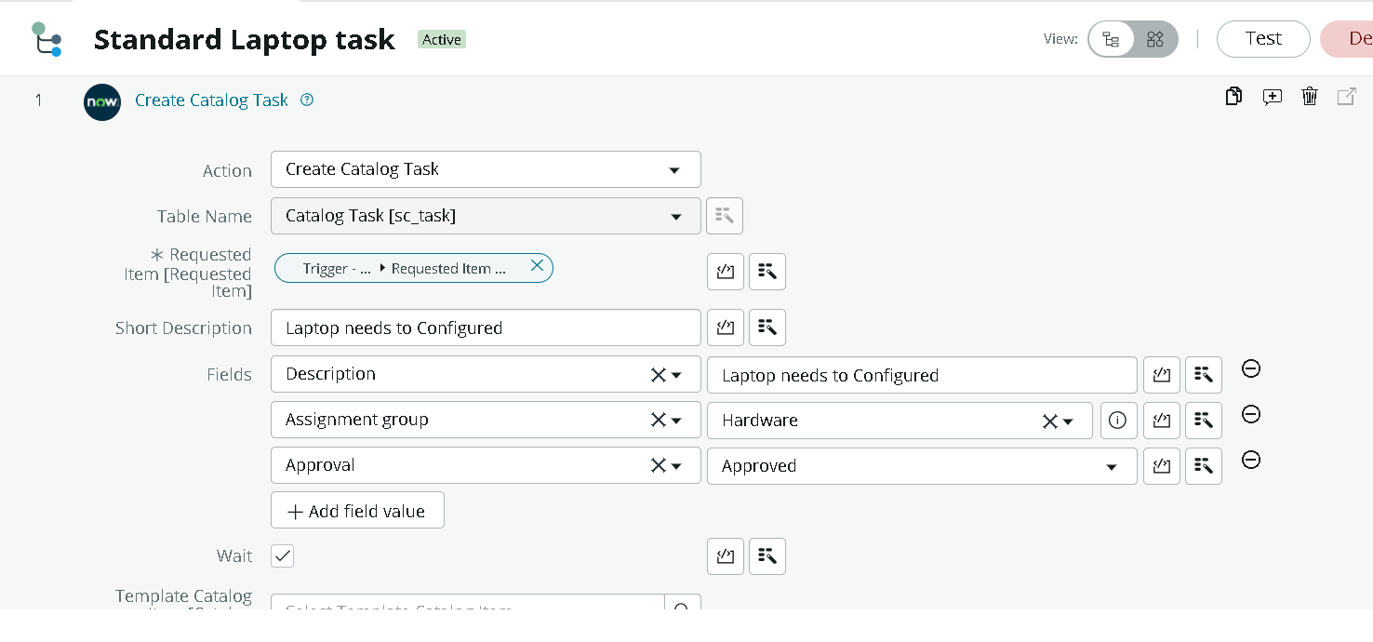
Figure 7.3: Create Catalog Task action
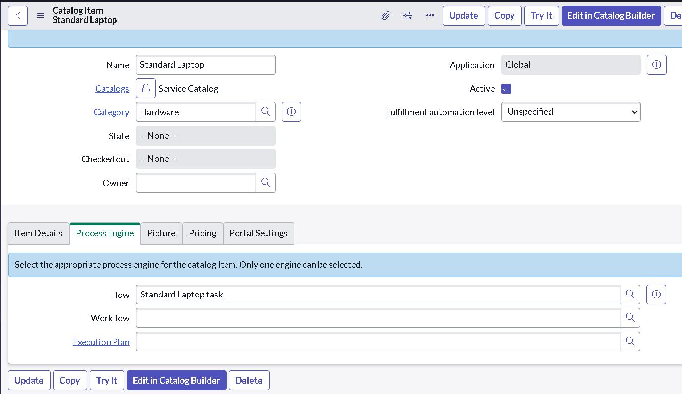
Figure 7.4: Flow attached to Standard Laptop in Process Engine
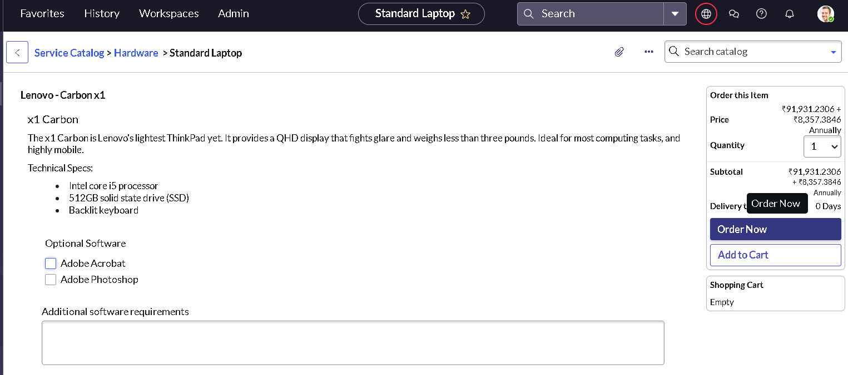
Figure 7.5: Standard Laptop catalog item – Order Now
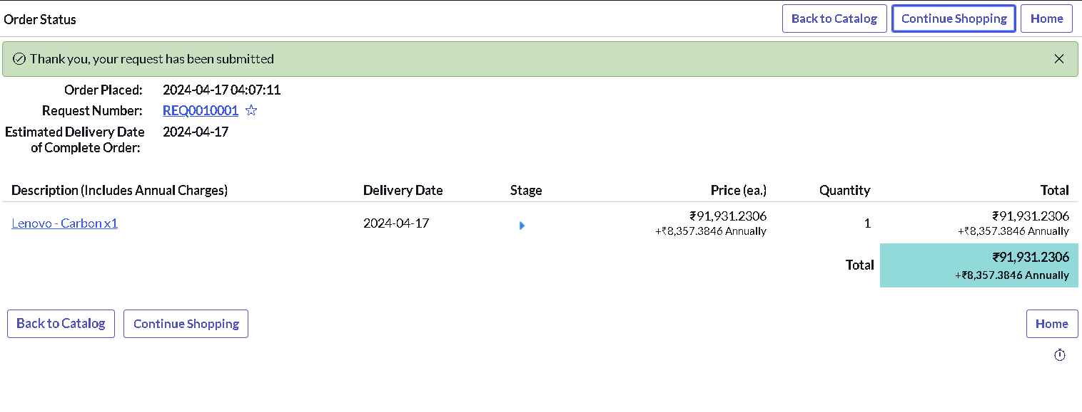
Figure 7.6: Order status with request number REQ0010001
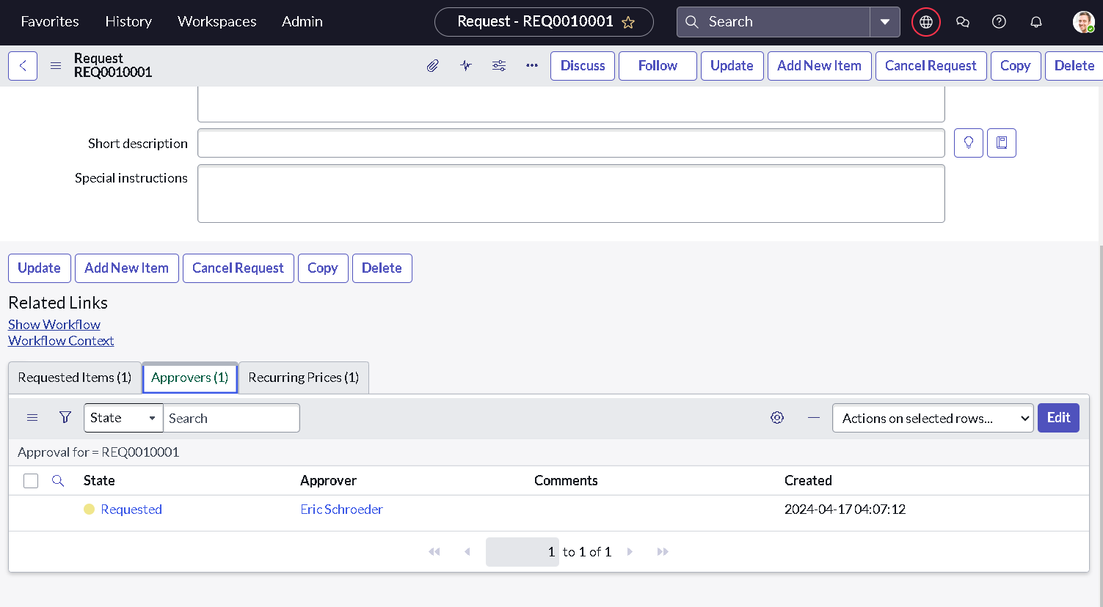
Figure 7.7: Approvers related list on the request
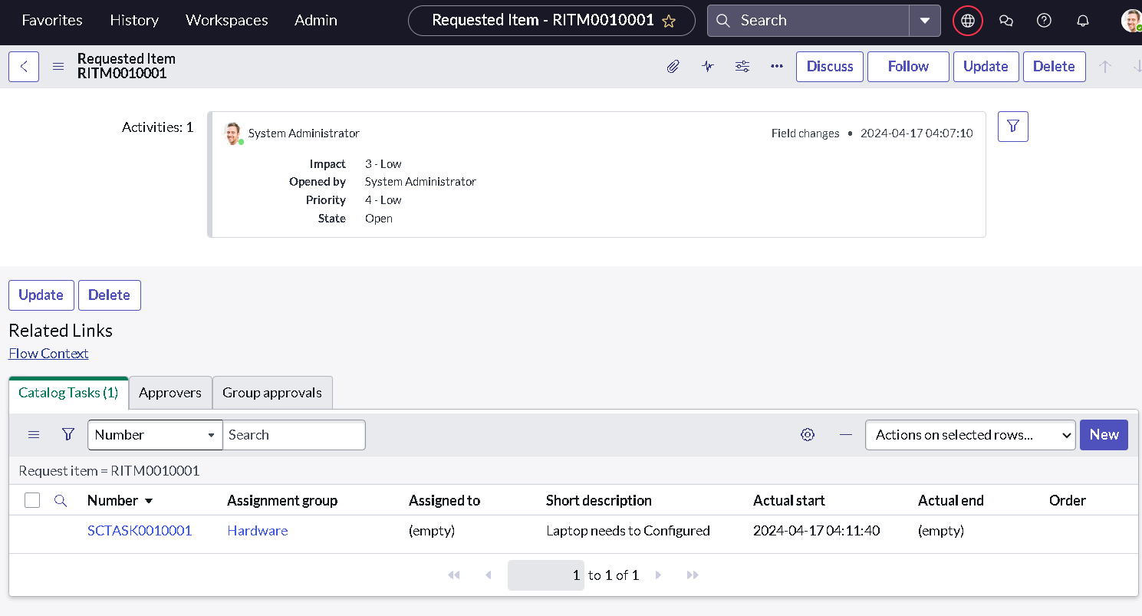
Figure 7.8: Catalog task SCTASK0010001 under RITM0010001
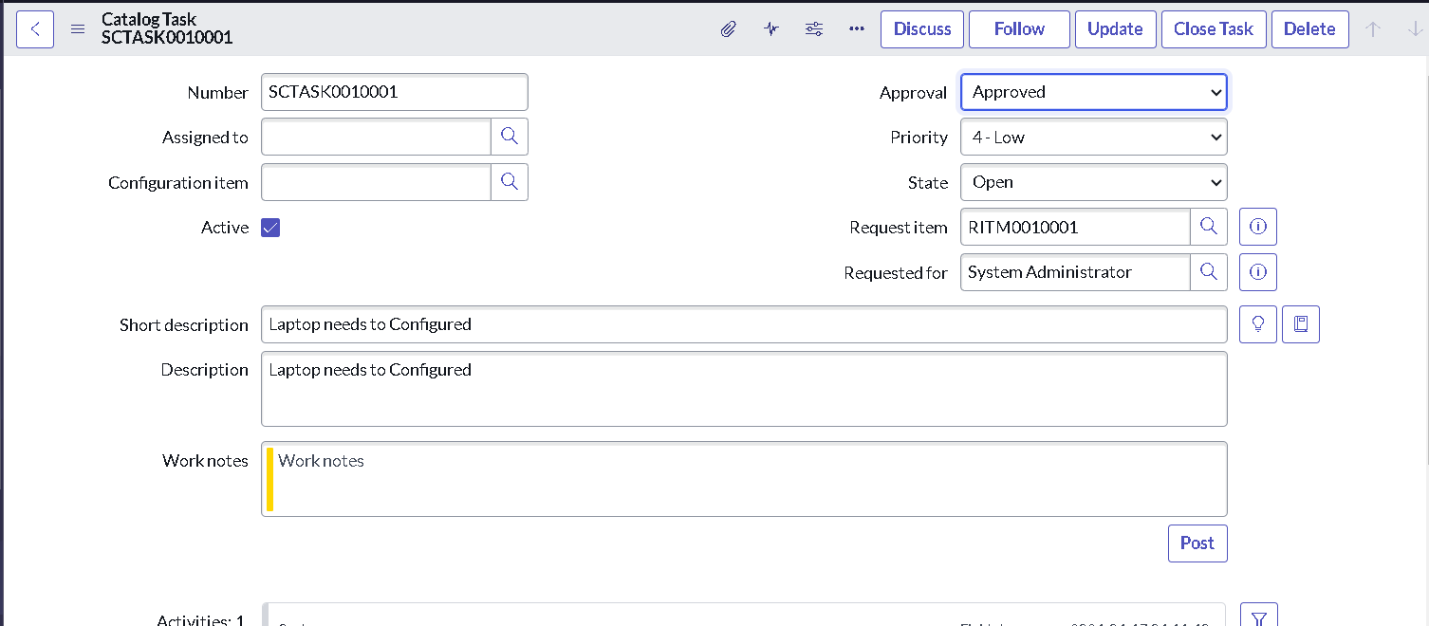
Figure 7.9: Catalog task with short description and approval

8. Advantages & Disadvantages
Advantages | Disadvantages
Catalog task is created automatically  Task is assigned to the Hardware team without manual work  Fewer missed or delayed configurations  Low-code solution, quick to build and change  Reusable for other catalog items | Works for the Standard Laptop item only until extended  Short description text is fixed, not built from request details  No notification to the requester yet  Needs a ServiceNow instance with Flow Designer

9. Conclusion
By automating the standard laptop procurement process with ServiceNow's Flow Designer, the project addresses the inefficiencies and reduces manual overhead. The workflow ensures timely configuration of laptops, minimises user wait times and improves productivity within the IT department. The solution optimises resource allocation and improves the user experience with a seamless and efficient procurement process.

10. Future Scope
- Add an explicit approval step or wait condition inside the flow so task creation is tied directly to approval.
- Send email or notification to the requester and the Hardware team when the task is created.
- Build the short description from request details such as requester name and selected software.
- Add SLA timers and a dashboard for configuration time.
- Extend the same pattern to other items such as monitors, mobile phones and software requests.

11. Appendix
Source code | Not applicable – the solution is configured in Flow Designer (low-code). Flow name: Standard laptop task (Global).
Dataset link | Not applicable
GitHub & Project Demo link | [Add your GitHub / demo video link here]

